**Brandon Hobbs**

**CS-360**

**January 11, 2023**

**Week 3 Assignment**

* **Create a new Android Studio project with an empty activity**. Complete the following in your set-up:

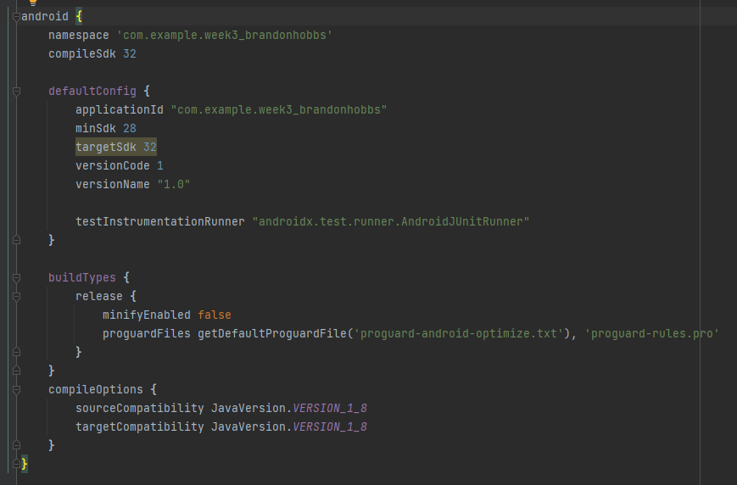

* **Identify the Android Studio elements using relevant names**. To accomplish this task, complete the following:
  + Name the button’s text as "Say Hello".
  + Label the ID of the button as “buttonSayHello”.

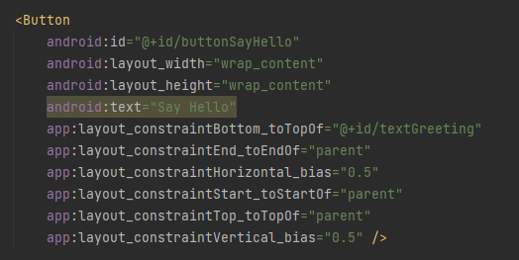

* + Remove all text from the TextView.
  + Label the TextView as “textGreeting”.  
    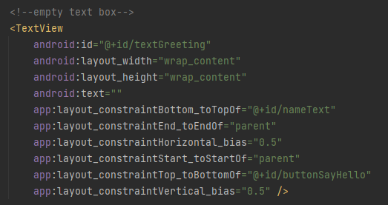
  + Label the Plain Text as “nameText”.  
    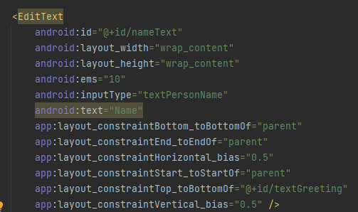

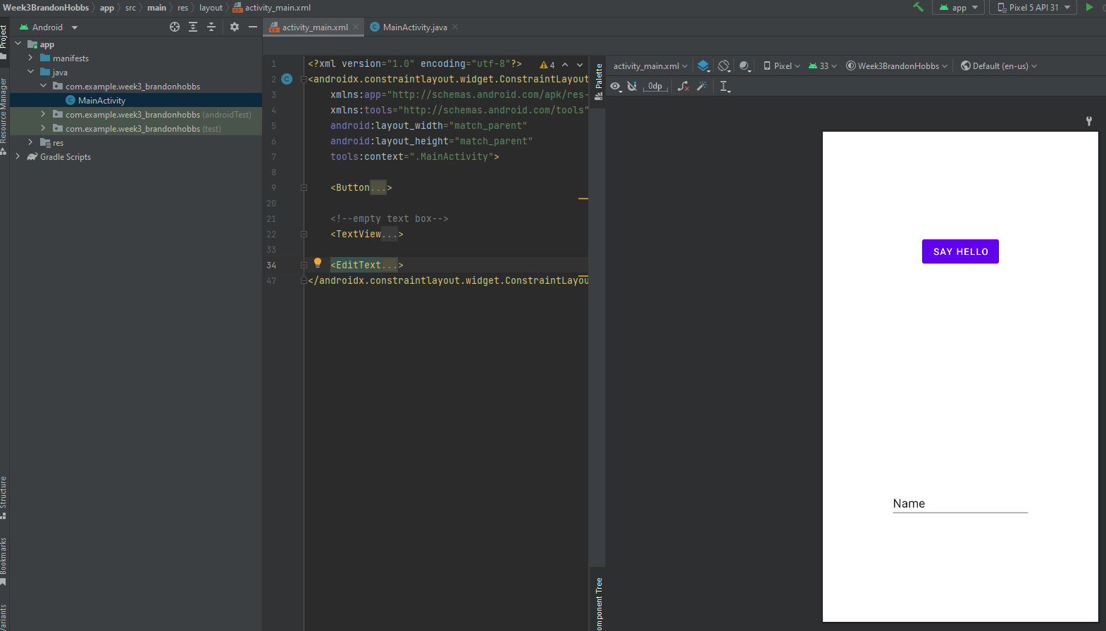

* **Discuss any challenges you experienced with Android Studio**No major issues were encountered. Most of my issues are just trying to get “my sea legs”. I am still exploring the IDE and all of its features. For example, you can right click elements and add constrains through the GUI – so I had to explore that feature a bit. I also had a little difficulty adding comment to the XML tags. I am used to being able to add inline comments but that kept causing errors. So, in the end, I just added my comment above the tag.